**Tracert:**

This command helps us to trace the request sent to the given link.

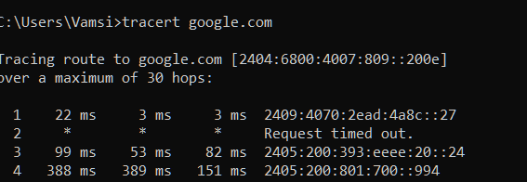

**PathPing :**

The advantages of PathPing over ping and traceroute are that each node is pinged as the result of a single command, and that the behaviour of nodes is studied over an extended time period, rather than the default ping sample of four messages or default traceroute single route trace. The disadvantage is that it takes a total of 25 seconds per hop to show the ping statistics.[[4]](https://en.wikipedia.org/wiki/PathPing#cite_note-4)

